**Bank Personal Loan Modeling**

Davood Aein

Shiley-Marcos School of Engineering, University of San Diego

Applied Data Mining (ADS-502-01)

Professor An Tran

Assignment due date: 4/15/2024

# Abstract

Using data mining techniques, this research aims to develop predictive models for personal loan acceptance in the banking industry. The growing demand for personal loans puts banks in a difficult position as they must assess loan applications quickly while minimizing risks. To create strong machine learning models that can predict a customer's likelihood of loan acceptance based on a variety of criteria, including age, family size, employment status, and income, our project will make use of historical loan data. Our models are designed to improve decision-making, speed up the loan process, and eventually increase customer satisfaction by streamlining loan approval procedures. Important stages of the research include feature engineering, data collection, exploratory data analysis, and model development. The accuracy, recall, and generalizability of four well-known algorithms—logistic regression, Random Forest, K-Nearest Neighbors (KNN), and decision trees—in predicting loan eligibility are examined. The results show that the Random Forest model performs better than the others, striking a balance between high accuracy and recall. However, there is still room for improvement as hyperparameters are continuously fine-tuned, highlighting the iterative nature of model evaluation and optimization in predictive analytics.

## Background

Creating predictive models for personal loan acceptance in the banking industry is the aim of this data mining research. Banks are faced with the problem of rapidly evaluating loan applications while limiting risks, given the rise in demand for personal loans. This project's inspiration stems from the realization of how crucial it is to predict loan approvals accurately to expedite the lending process, enhance customer happiness, and reduce the possibility of default losses. This project's main goal is to use past loan data to develop strong machine learning models that can precisely forecast a customer's likelihood of being approved for a personal loan based on a variety of factors, including age, family size, employment status, and income. By doing so, banks can optimize their loan approval processes, enhance decision-making, and ultimately, improve customer experience.

We are approaching this project in multiple critical phases. First, we will gather and thoroughly comprehend all pertinent data from Thera Bank's databases, including financial history, campaign response statistics, and client profiles. The next step will be exploratory data analysis (EDA), which will identify patterns, correlations, and possible outliers that could have an impact on model development by revealing crucial details about the dataset's properties. The next step will be featuring engineering, where we create new features or improve the ones that already exist to better represent the complex relationships found in the data while maintaining robustness by removing outliers and missing values. Moving forward, we will delve into model development, where we will meticulously select, and train machine learning algorithms tailored to our objectives. Logistic regression, decision trees, KNN, and Random Forest are among the models we will consider, focusing on interpretability, scalability, and predictive accuracy. Upon completion of model training, we will evaluate their efficacy using pertinent metrics such as accuracy, precision, recall, and F1-score to derive actionable insights and identify areas for campaign strategy enhancement.

Using verified models and a thorough grasp of the data, we will create focused campaign strategies to maximize Thera Bank's marketing initiatives. In addition to raising conversion rates, these suggestions will offer directions on how best to allocate funds and use available resources. In the end, we hope to provide Thera Bank with the knowledge and resources required to improve their marketing initiatives and successfully meet their conversion rate goals through our thorough research and tactical recommendations.

# Methodology

The goal of this project is to investigate methods for Thera Bank's management to convert its liability clients into personal loan customers (while retaining them as deposits). The bank's liability customer campaign from the previous year had a successful conversion rate of more than 9%. This has prompted the retail marketing department to design more effective target-marketing programs to boost the success rate on a low budget. The dataset acquired from Kaggle and accessed through Excel. 5000 data points make up the dataset. The 14-column dataset consists of 13 columns (ID, Age, Experience, Income, ZIP Code, Family, Education, Mortgage, Personal Loan, Securities Account, CD Account, Online, and CreditCard) categorized by int64 type. a single column for the CCAvg object type. The Personal Loan column is the target; the other columns are features. We will investigate this further because there isn't a missing value, but there might be faulty values. Also, there are no duplicated values. There are some negative values in the Experience column. We therefore change the negative numbers into positive ones since we presume that the negative data was positive, and we do not have access to the data owner. We can remove ID and Zip Code columns since they are not required for creating a model. Figure 1 shows the outliers for selected columns. Mortgage has the most outliers.

## Figure 1

*Outliers for selected columns*

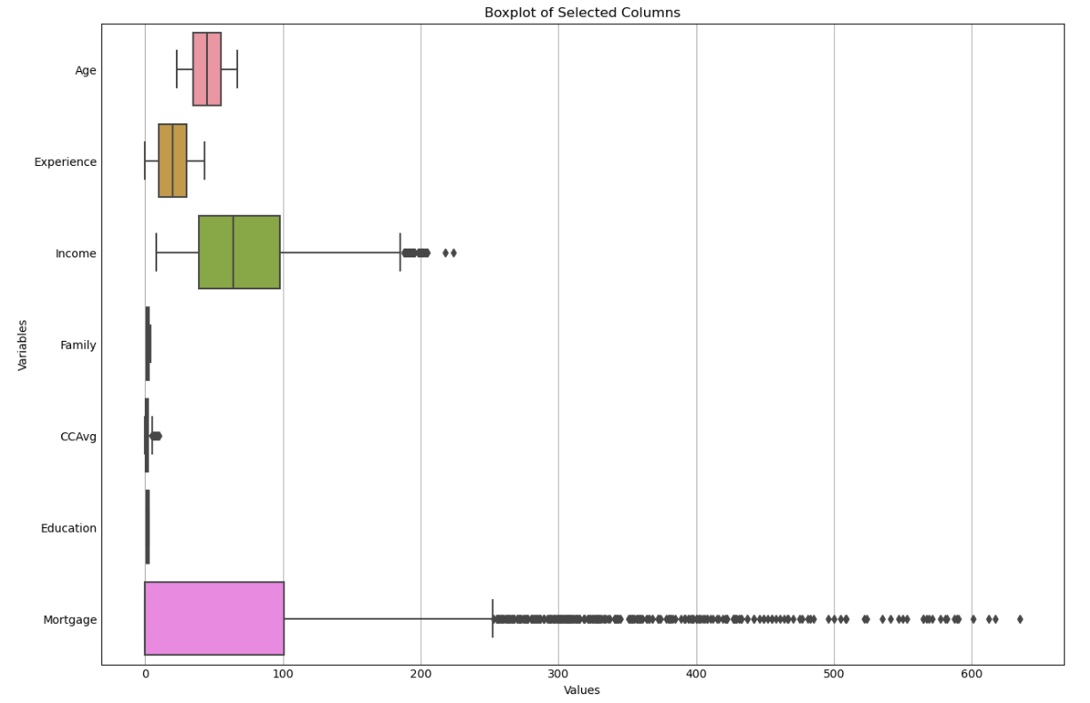

Although the dataset contains both numerical and categorical qualities, the numbers are used to represent all the categorical data. Furthermore, pre-processing the data is an intriguing but manageable element of the data because some of the predictor variables are highly skewed (long tailed).  Among these 5000 customers, only 480 (= 9.6%) accepted the personal loan that was offered to them in the earlier campaign.

To assess machine learning models for predicting eligibility for personal loans, we use a methodical process. Data preparation is the first step, where we define our dataset's feature matrix x and target variable y. Next, we initialize lists to contain important evaluation metrics, including Model, FPR, TPR, and others. These indicators are essential for evaluating our models' performance. In addition, we define several visualization functions, such as Perform_cross_val and plot_confusion_matrix2, which help to visualize model performance and make it easier to compare models. Ultimately, data separation, model fitting, prediction, evaluation metric computation, and result visualization are all included in the modeling function. This comprehensive approach allows us to systematically evaluate and compare the performance of multiple machine learning models in predicting Personal Loan eligibility.

**Figure 2**

*Heatmap of correlations*

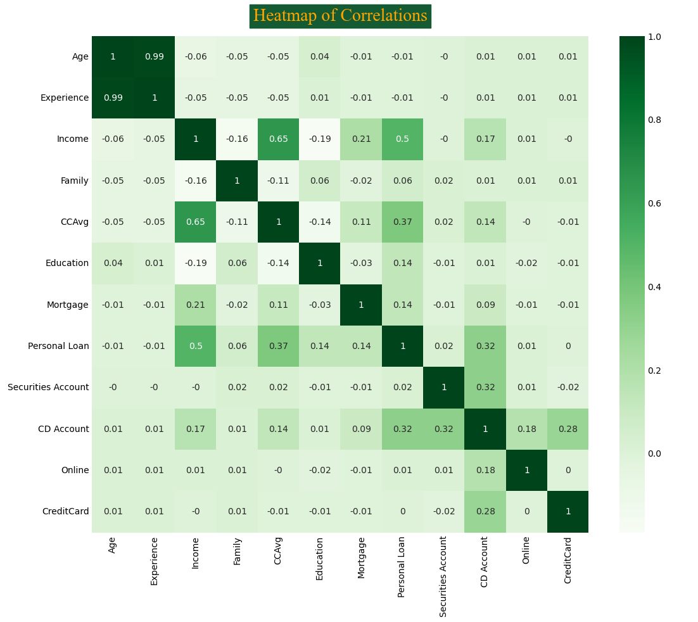

In figure 2, the correlation coefficient in the cell where the Experience column and Age row overlap is 0.99. It is not unexpected that there is a very high positive link between experience and age. The correlation coefficient in the cell where the Income row and CCAvg column meet is 0.65. This suggests that there is a somewhat significant positive link between average credit card load and income, meaning that higher earners typically have larger credit card balances. A correlation coefficient of 0.14 is displayed in the cell where the Mortgage row and Personal Loan column overlap. This suggests that there is a marginally favorable link between personal loans and mortgages.

## Logistic Regression

A basic statistical model used extensively in predictive analytics and categorization is logistic regression. It works by converting the success odds into probabilities that are restricted to values between 0 and 1. Predicted probability for each observation can be computed by logistic regression's iterative optimization of coefficients to maximize the log likelihood function through maximum likelihood estimation. The Hosmer-Lemeshow test is frequently used to evaluate the model's quality of fit. Exponentiating beta estimates produces odds ratios that can be used to compare event-associated outcomes and aid in result interpretation (Pidstrigach, 2022).

Personal Loan eligibility is estimated in this section using a logistic regression predictive model. The dataset is first split into training and testing sets, with a 20% test size at the beginning. During the data split, the Stratify argument is used to make sure that the class labels in both sets are distributed proportionately. The logistic regression model is then subjected to cross-validation to assess its performance using accuracy and recall, two distinct scoring criteria. A ten-fold cross-validation shows a mean accuracy of roughly 95.12% for accuracy evaluation. In the case of recall evaluation, the average recall score over ten times is roughly 63.04%. An original logistic regression model is trained utilizing the full training dataset after cross-validation, and it achieves an accuracy of 95.2% and a recall of 63.28% on the test dataset. The classification report offers a thorough evaluation of the model's performance by outlining accuracy, f1-score, and support metrics for every class. Grid search is then used to fine-tune the model's hyperparameters, improving the model's performance even more and producing a better logistic regression model with higher accuracy and recall ratings. This iterative model evaluation and refining procedure emphasizes how important hyperparameter tuning is to maximize predictive performance. Furthermore, the influence of different test sizes on model performance is investigated, highlighting the significance of test size selection for obtaining strong model generalization. Overall, these results highlight the utility of logistic regression in Personal Loan eligibility prediction, however test size modification and hyperparameter optimization offer potential avenues for improvement.

**Figure 3**

*improve model by changing test_size*

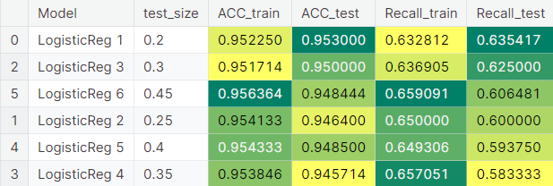

## K-Nearest Neighbors (KNN)

The K-Nearest Neighbors (KNN) algorithm, a foundational method in supervised machine learning, relies on the concept of proximity-based prediction. During training, KNN memorizes the dataset, and during prediction, it identifies the k-nearest neighbors to a given data point in the feature space (Musuvathi, 2024). To forecast target variables based on input features, we implemented the K-Nearest Neighbors (KNN) algorithm for classification tasks in this study. We trained the KNN algorithm on our dataset and assessed its performance using the knn_model function. We used several methods, including dividing the data into training and testing sets, estimating model accuracy and recall by cross-validation, and optimizing model performance through parameter tuning with GridSearchCV. According to our findings, the KNN model demonstrated encouraging rates of recall and accuracy; the optimal results were obtained with a test size of 0.2 and a value of k equal to 3. Additionally, our findings underscore the importance of considering both accuracy and recall metrics when assessing model effectiveness, particularly in classification tasks where class imbalances may be present. Overall, this study highlights the efficacy of the KNN algorithm in classifying datasets and provides insights into optimizing its performance for real-world applications.

## Decision Tree

A basic data mining technique called classification uses attribute variables to group new occurrences into predetermined classes. The decision tree method is one of the most often used techniques for classification tasks among all the other methods available. Because they are easy to read and may forecast potential classes through simple partitions, decision trees are especially attractive. In essence, a decision tree is a flexible model that may be used for both regression and classification applications. Regression tasks are more appropriate when the class variable is numerical, although decision trees are useful in classification when the class variable is nominal (Alharbi, 2024). Cross-validation was the first step in our assessment of the Decision Tree model's recall and accuracy. We were able to attain a mean accuracy of roughly 98.15% across the folds by using 10-fold cross-validation. Furthermore, a mean recall of almost 83.83% was obtained from the cross-validation, demonstrating the model's accuracy in identifying positive cases. Next, we evaluated the Decision Tree model's initial performance in the absence of any pruning. With 98.6% accuracy on the test set and a flawless 100% accuracy on the training set, the model demonstrated remarkable accuracy results. The model's recall score on the test set was roughly 89.58%, indicating that there is still opportunity for development in accurately recognizing positive cases, despite the model's high accuracy.

To find the ideal hyperparameters, we used a grid search to further enhance the model's performance. The grid search found the ideal hyperparameters, which attempted to balance model complexity and generalization. These hyperparameters included criterion='gini, max_depth=5, min_samples_leaf=14, and min_samples_split=2. We used post-pruning approaches to reduce overfitting and improve the model's capacity for generalization. We identified the effective alphas and pruned the tree in accordance with our analysis of the cost-complexity pruning strategy. Recall scores were plotted against various alpha values to verify that the pruned model performed well in terms of generalization without overfitting. Recall improved significantly to 91.67% on both the training and test sets.

Upon closer examination, the most significant characteristics in forecasting loan approval were identified. The selection of Education, Income, Family, CCAvg, Securities Account, Online, and Personal Loan as the primary variables highlights their importance in the selection process. Ultimately, we adjusted the test size parameter to improve the model and found that the best-performing model had a test size of 20%. The goal of this optimization procedure was to increase the model's resilience and dependability in practical settings, guaranteeing its efficacy in accurately and reliably predicting loan acceptance.

**Figure 4**

*Changing test size*

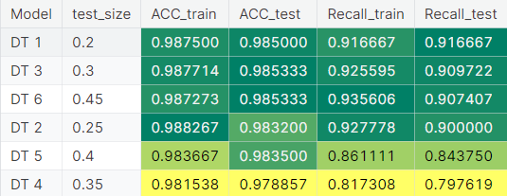

## Random forest

We evaluate Random Forest models' effectiveness for the given classification job. Using a 20% test size and stratification to account for the class distribution, we first divide the data into training and testing sets. After that, the accuracy and recall of the model are estimated using cross-validation. Without any pruning, the first Random Forest model is built and its performance metrics are analyzed. To optimize the model, parameter adjustment is then carried out. Iterative parameter exploration is carried out, with a focus on important parameters like bootstrap sample size, number of features, and tree depth, due to the computational cost of grid search. The Random Forest model's ideal configuration is found by this iterative approach. After fine-tuning the parameters, multiple iterations of the Random Forest model are assessed, with the test size varied to observe the effect on model performance. To choose the best model configuration, the results are totaled and examined. Based on performance metrics over a range of test sizes, the Random Forest model with the best overall performance is finally chosen.

**Figure 5**

*Comparing different test size*

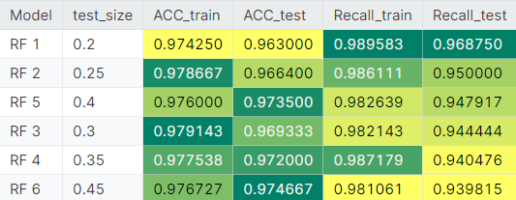

# Result

Our use of logistic regression to predict personal loan eligibility reveals a model with excellent performance metrics. With a recall of 63.5% and an accuracy of 95.3%, the logistic regression model shows that it can produce precise predictions. Still, there is room for improvement, especially when it comes to improving the recall of the model by using grid search to adjust its hyperparameters. Additionally, the analysis of various test sizes highlights how important it is to optimize this parameter for robust model generalization, suggesting potential directions for future development and improvement.

When estimating a person's eligibility for a personal loan, the K-Nearest Neighbors (KNN) algorithm produces encouraging results. In proximity-based prediction, the KNN model demonstrates its effectiveness with an accuracy of 96.8% and a recall of 71.9%. Notably, a test size of 20% and a value of k equal to 3 yield optimal performance, highlighting the significance of parameter selection in optimizing model efficacy. These results highlight KNN's promise as a dependable tool for classification jobs and provide insightful information about how to maximize its effectiveness for practical uses.

Our investigation into decision tree models for predicting personal loan eligibility reveals a very precise predictive tool. With a recall of 91.7% and accuracy of 98.5%, the decision tree model performs admirably. Even with its high accuracy, there is always room for development, especially in terms of correctly detecting positive situations. Using post-pruning techniques and hyperparameter adjustment, we improve the model's ability to generalize, leading to notable gains in recall scores on training and test sets. These results illustrate decision tree models' efficacy in categorization tasks and point to areas that could want more improvement.

Based on our data, the Random Forest model shows itself to be the best at predicting eligibility for personal loans. At 96.3% accuracy and 96.9% recall, the Random Forest algorithm shows strong prediction ability and dependability. The model's design is optimized by iterative parameter adjustments and fine-tuning, which results in consistent gains in performance measures over a range of test sizes. According to our research, the Random Forest algorithm is a very good way to estimate a person's eligibility for a personal loan while maintaining a high level of accuracy and recall. Furthermore, the iterative process of optimizing and evaluating models emphasizes how crucial ongoing improvement is to predictive analytics.

Finally, our analysis demonstrates how well the Random Forest, KNN, decision tree, and logistic regression algorithms predict a borrower's eligibility for a personal loan. Even though every model has advantages and disadvantages, the Random Forest approach proves to be the most efficient one since it strikes a compromise between high accuracy and recall. Nevertheless, additional investigation and improvement of each model's hyperparameters may produce even better outcomes, highlighting the iterative character of model assessment and optimization in predictive analytics.

# Reference

Alharbi, A. A. (2024). Classification Performance Analysis of decision tree-based algorithms with noisy class variable. *Discrete Dynamics in Nature and Society*, *2024*, 1–10. https://doi.org/10.1155/2024/6671395

Musuvathi, A. S., Archbald, J. F., Velmurugan, T., Sumathi, D., Renuga Devi, S., & Preetha, K. S. (2024a). Efficient improvement of energy detection technique in cognitive radio networks using K-nearest neighbour (KNN) algorithm. *EURASIP Journal on Wireless Communications and Networking*, *2024*(1). https://doi.org/10.1186/s13638-024-02338-8

Pidstrigach, J., & Reich, S. (2022). Affine-invariant ensemble transform methods for logistic regression. *Foundations of Computational Mathematics*, *23*(2), 675–708. https://doi.org/10.1007/s10208-022-09550-2

# Appendix

